Vocabulary Terms: Evolution of Populations NAME______________________
13.  __________________  __________________ | Situation in which allele frequencies remain constant;  Mathematical equation to study changes in allele frequency called Hardy-Weinberg  equation |  | Conditions:  1.  2.  3.  4.  5. |  | Change in a kind of organism over time; Occurs in a population over many generations but not in individuals |  | 4 modes:  1.  2.  3.  4. |  | 1.  ___________________
14.  __________________ | Formation of a new species |  | Two main forms:  1.  Physical barrier between populations  2.  Populations are separated for reasons other than physical barrier |  | Inherited characteristic that increases an organism’s chance of survival; alter traits to affect fitness.  Result of natural selection—can include physical traits or even intangible like lifespan |  | 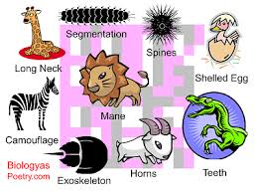 |  | 2.  ___________________
15.  __________________  __________________ | Separation of species or populations so that they cannot interbreed and reproduce fertile offspring |  | Types:  1.  i.e courtship rituals, bird songs  2.  i.e river, mountain  3.  i.e. seasonal, nocturnal vs. diurnal |  | Modification in structure form and function in an organism, differs from other organisms in same species; population must exhibit differences in phenotypes in individuals |  | Causes:  1.  Any change in DNA sequence  2.  Such as crossing over or independent assortment in gamete formation |  | 3.  __________________
Hypothetical example of speciation:  Darwin’s finches | Draw flow chart showing 5 steps: (use book) |  |  |  | Process by which individuals that are better suited to their environment survive and reproduce most successfully; survival of fittest. Can affect single gene traits i.e. widow’s peak, or polygenic traits i.e. height |  | Conditions:  1.  2.  Has to be able to be inherited; if not then it cannot be selected for or against  3. |  | 4.  __________________  ___________________
5.  ________ _________ |  | Consists of all genes (including all alleles or gene forms) present in a  population |  | 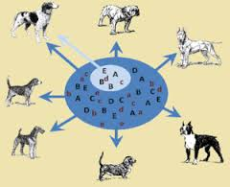 |  | Form of natural selection where single distribution curve splits into two; occurs when individuals at upper and lower ends of the curve have higher fitness than individuals near the middle; Extremes do better than more common forms |  | 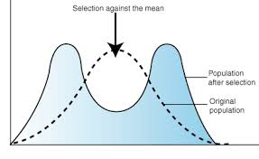 | 9.  __________________  __________________
6.  __________________  ___________________ |  | Number of times an allele occurs in a gene pool compared with the number of times other alleles occur.  Evolution is any change in the relative frequency of alleles in a population |  | 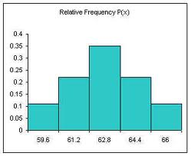 |  | Random change in allele frequencies that occur in small populations |  | 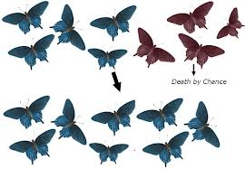 | 10.  __________________  __________________
7.  ___________________  ___________________ |  | Form of natural selection  Where entire distribution curve moves; occurs when individuals at one end of curve have higher fitness than individuals in the middle or other end of curve. |  | 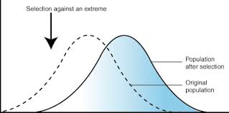 |  | Change in allele frequencies as a result of the migration of a small subgroup of a population; this is a special case of genetic drift |  | 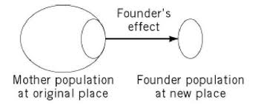 | 11.  ___________________  ___________________
8.  ____________________  ____________________ |  | Form of natural selection when center of distribution curve remains in its current position; occurs when individuals near center of the curve have higher fitness than individuals at the ends. |  | 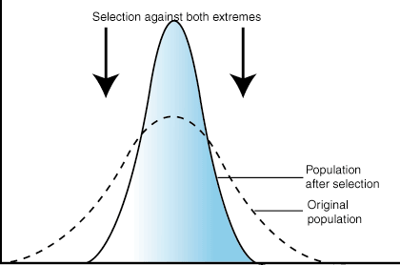 |  | Change in allele frequencies as genes from one population are incorporated into (joined with) another.  Have to be able to inter breed. |  | 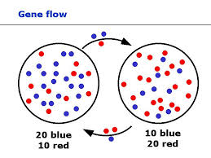 | 12.  _________ _________

