Chordates and Fishes Notes
Characteristics of Chordates
- A chordate is an animal that in some stage of development has:
  - Notochord- dorsal rod of specialized nerves
  - A dorsal nerve chord- hollow tube just above the notochord
  - Pharyngeal pouches- small out pockets of the anterior gut
- Notochord exists only in the embryo
- Notochord replaced by an endoskeleton
- Endoskeleton grows as the animal grows
- Brain connected to a network of complex sensory organs
- In lower chordates (fishes amphibians) pharyngeal pouches evolved into gill slits
- In terrestrial vertebrates pharyngeal pouches evolved into structures in throat and ear
CLASSIFICATION
Phylum Chordata has 3 subphyla
  - Urochordata
  - Cephalochordata
  - Vertebrata
Subphylum Urochordata
- Hollow barrel shaped urochordates are commonly called tunicates
- Tunicates also know as sea squirts
Subphylum Cephalochordata
- Marine organism (usually shallow water)
- Best represented by a blade-shaped translucent animal called Branchiostoma
Subphylum Vertebrata
- Vertebrata named for vertebrates
- Brain protected by an outer skull
- Backbone and skull make up the axial skeleton
- Organs of vertebrates are organized into 10 systems
Skeletal, muscular, integumentary, digestive, respiratory, circulatory, excretory, immune, nervous, and reproductive
EVOLUTION AND CLASSIFICATION OF FISHES
- Three classes of vertebrates: Agnatha; Chondrichthyes; and Osteichthyes
- Fishes are the most numerous of all vertebrates and most widespread in their distribution
Adaptations
- Because water is 800 times the density of air, it affects both the body and mobility of fishes: adaptation for buoyancy (trapping of gas inside their body: gas bladder in order to regulate their vertical position)
- Ability to swim: a streamlined shape and muscular tail enables them to move rapidly through the water; paired fins allow them to maneuver easily left or right, up or down, and backward and forward; the mucus reduces friction
- Scales limit chemical exchanges through the skin; exchanges occur through the membranes of the gills: the external respiratory organs
- Lateral line system: consists of a row of sensory structures that run the length of the body and connected by nerves to the brain; detects vibrations
AGNATHA “JAWLESS”
- Do not have a lateral line system
- 45 species of lampreys (fresh water) and hagfish (oceans)
- Cyclostomes “round mouths” ; have neither plates nor scales
- Notochord, eel-like shape, a cartilaginous skeleton, and unpaired fins
Lampreys:
- free living or parasitic; adapted for sucking blood and body fluids of other fish
- highly developed sense of smell: nasal pore leads to olfactory sacs that connect with olfactory lobes
- Feeding: attach by suction, tear a hole with toothy tongue, secrete chemical to prevent clotting
- do not have a stomach: mouth, esophagus, a straight intestine, and associated glands
HAGFISH
- Bottom dwellers in cold marine waters
- Scavengers of dead and dying fish on ocean bottom
- Feed by sawing the fish with its toothed tongue from the inside out
- Extremely flexible to avoid capture or to clean the slime off after self-defense secretions
- When not feeding they remain hidden in burrows on the ocean floor
CHONDRICHTHYES
- Sharks, skates, and rays
- They have skeletons of cartilage, not bone
- Also have movable jaws and skeletons with paired fins
Sharks
- Sharks are scavengers that eat injured fish, carrion, garbage and other waste from ships as well as animals such as seals, turtles, birds, whales, crabs, and a wide range of fishes.
- The shark’s mouth has 6 to 20 rows of backward-pointing teeth. They can detect blood from an injured animal as far as 500 miles away.
- They swim with a side-to-side motion of their asymmetric tail fins. Behind their heads are pectoral fins that jut out of their bodies like the wings of a plane.
- Gas exchange requires a continuous passage of water over a shark’s gills.
Rays And Skates
- Skates are a family of flat-bodied rays found in warm and temperate seas. They have eyes located on the upper surface of the body while the mouth and gills are located on the lower surface.
- Their color makes them almost invisible because when another animal looks down on them, they are camouflaged with the darkness of the sea bottom. When looked up from underneath, the animal is camouflaged with the light from the sun.
- Water enter their gill through two openings called spiracles atop their heads. Most feed on mollusks and crustaceans.
OSTEICHTHYES
- Osteichthyes make up most of the vertebrate population in fresh water and in salt water.
- Lobe-finned fishes, or coelacanths, have paddle like fins with fleshy bases.
- Lungfishes have gills where gas exchange takes place between water and the blood. They burrow unto the mud and cover themselves in mucus to stay moist until the pond refills.
- Ray-finned fishes have fins that are supported by the long bones called rays. They are the most familiar fishes and include snakelike eels, yellow perch, cave fish, herring, and lantern fish.

BONY FISH
Morphology--External Anatomy
Body Structure
- Distinct head, trunk, and tail regions
- On each side of head is an operculum
-Hard plate that opens at rear and covers and protects gills
- Strong muscles along dorsal backbone thrust tail from side to side
FINS
- Thin fan-shaped membranes
- Richly supplied with blood
- By raising and lowering fins, regulate body temperature
- Supported by rays or spines
-Rays- bony yet flexible
-Spines- bony and rigid
- Adapted for swimming and guiding fish through water
- Caudal fin extends from tail
-Moves from side to side and amplifies swimming motions
- 2 dorsal fins, one anterior and one posterior, and ventral anal fin
-Help keep fish upright and moving in straight line
- Paired pelvic fins and pectoral fins
-Used to steer, brake, move up and down, and even back up
-Orient body when at rest
INTEGUMENTS
- Skin covered with scales
-Thin, round disks of highly modified bone that grow from pockets of skin
-Overlap like roof shingles, all pointing toward tail to minimize friction
-Grow during entire life of fish
-Adjusting growth pattern to food supply
  - Scales grow quickly when food is abundant and slowly when scarce
- Skin contains pigmented chromatophores
-Create various color patterns

INTERNAL ANATOMY
- Bone is living tissue in which cells deposit minerals, primarily calcium
- Bone can:
  - Grow
  - Support many times its own weight
  - Heal if broken
  - Resists bending or breaking when stressed by muscle or blows
- Major parts of fish skeleton
  - Skull
  - Spine- made up of many cones, vertebrae with cartilage pads in between
  - Ribs
DIGESTIVE SYSTEM
- Carnivores
- Jaws armed with many sharp teeth that point inward to keep smaller fish and other prey from escaping
- Tongue anchored and immobile
- Lined with nerve cells, helps detect chemicals in environment
- Food passes from mouth pharynx esophagus stomach
- Digestion takes place in out pockets of stomach called pyloric ceca
- Liver and pancreas secrete digestive enzymes (bile and insulin) that help break down food
Undigested material leaves through ventral anus
CIRCULATORY SYSTEM
- Adapted for rapid swimming and other high-performance activities
- Consists of:
-Two-chambered heart
  - Atrium- collecting chambers
  - Ventricle- pumping chambers
-Blood vessels
-Blood containing red and white blood cells
- Heart pumps blood through arteries to small, thin-walled vessels called capillaries in gills blood picks up oxygen gas from releases carbon dioxide into water blood moves to body tissues, where nutrients and wastes are exchanged blood returns to heart through veins
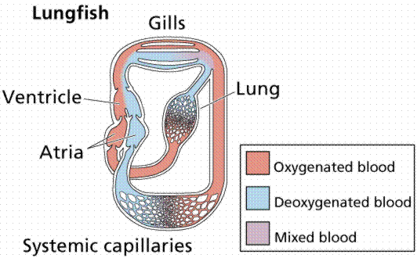

RESPIRATORY AND EXCRETORY SYSTEMS
- Gills adapted for gas exchange
- Consists of four sets of curved pieces of bone on each side of head
- Each has double row of thin projections called gill filaments richly supplied with capillaries
- Large surface area allows rapid gas exchange
- Excrete nitrogenous wastes from body, but task carried out primarily by kidneys
- Kidney’s filter out dissolved chemical wastes from blood
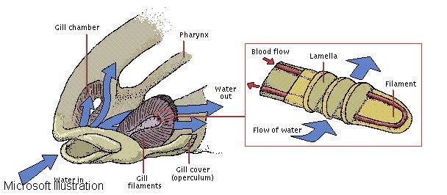
GAS BLADDER
- Gas bladder or swim bladder
-Thin-walled sac in abdominal cavity
-Contains mixture of oxygen, carbon dioxide, and nitrogen obtained from bloodstream
-By regulating amount of gas in sac, fish adjust overall density and thus move up or down in water or hover at given depth
NERVOUS AND SENSORY SYSTEM
- Nervous system consists of:
-Brain- consisting of five paired lobes
  - Optic lobes- largest, at center; receive impulses from eyes and other sense organs; signal muscles to move
  - Olfactory lobes- anterior lobes; respond mainly to smells
  - Cerebrum- anterior lobes; respond mainly to smells
  - Cerebellum- posterior of brain; coordinates muscles
  - Medulla oblongata- regulates internal organs
-Spinal cord
-Nerves that lead to and from all parts of body
- Major sense organs connected directly with brain via cranial nerves
- Spinal nerves connect spinal cord with internal organs, muscles, and sense organs
Also carry impulses to brain from lateral line system
REPRODUCTION
- Sexes are separate
- Eggs produced by ovaries in female; sperm produced by testes in male; both released through opening just rear of anus
- Fertilization of eggs takes place externally
- Young fish hatch within hours of warm water or after many weeks in cold water
- Number of eggs bony fish may lay varies considerably
- Some bear live young
- Female receives sperm during mating, and fertilization is internal
- Carries eggs in body until young are born
- Spawn- reproduce
EVOLUTION
- The first known vertebrates: Jawless fish in Class Ostracodermi; covered by bony plates (modified scales); 540 million years ago
- The Class Agnatha, jawless fishes, are similar to ostracoderms (ancestry: Osteichtyes and Chondrichthyes; jaws that evolved from ostracoderm gills)
- Relatives of jawed, bony, and cartilaginous fish appeared 400 million years ago
- 2 vital adaptations: 1.) evolution of a pouch in posterior portion of the mouth that served as a lung. 2.) the emergence of fins supported by bony lobes projecting from the body ( lung fish and lobed-finned fish); enabled shallow water species to survive droughts
- Prototype lungs evolved into lungs in land vertebrates and lobed fins into limbs ( lobed-finned fish ancestors of amphibians)

